Cloud Architect, Cloud Network Engineer, Cloud Administrator

Compute, Networking

**Lab Details**

1. This lab walks you through the steps to creating VPC Flow Logs.
2. You will practice using VPC flow logs with AWS VPCs.
3. Duration: **45 minutes**.
4. AWS Region: **US East (N. Virginia) us-east-1**

**Introduction**

Amazon Virtual Private Cloud

* Amazon Virtual Private Cloud (Amazon VPC) lets you provision a logically isolated section of the AWS Cloud where you can launch AWS resources in a virtual network that you define. You have complete control over your virtual networking environment, including a selection of your own IP address range, creation of subnets, and configuration of route tables and network gateways.
* You can use both IPv4 and IPv6 in your VPC for secure and easy access to resources and applications.
* You can easily customize the network configuration of your Amazon VPC. For example, you can create a public-facing subnet for your web servers that have access to the internet.
* You can also place your backend systems, such as databases or application servers, in a private-facing subnet with no internet access. You can use multiple layers of security, including security groups and network access control lists, to help control access to Amazon EC2 instances in each subnet.

**Architecture Diagram**

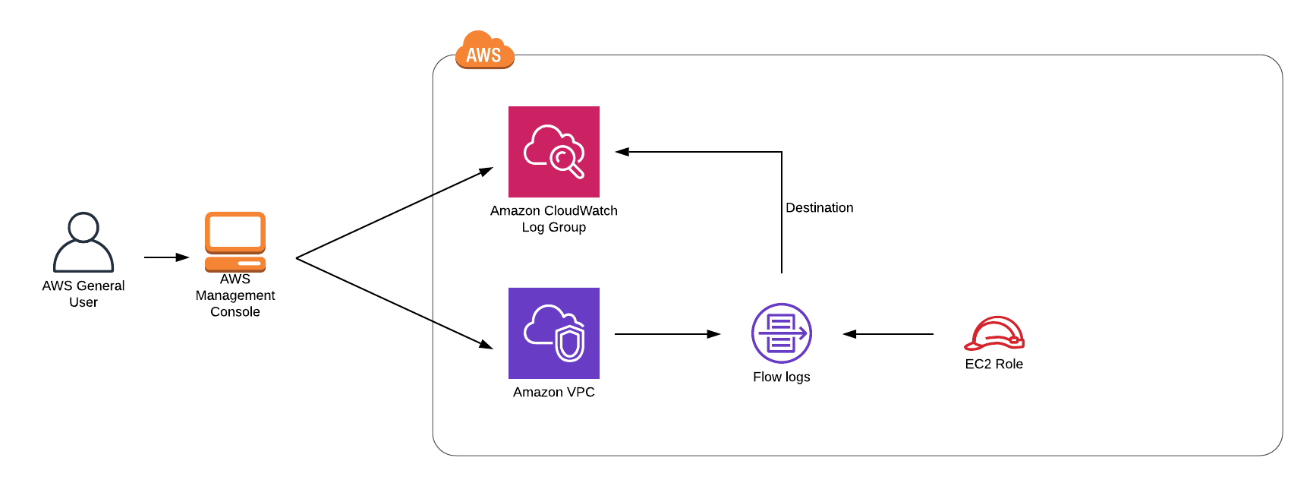

**Task Details**

1. Sign in to the AWS Management Console.
2. Create CloudWatch Logs.
3. Create a VPC.
4. Create VPC Flow Logs

**Launching Lab Environment**

     1. To launch the lab environment, Click on the  button.

     2. Please wait until the cloud environment is provisioned. It will take less than a minute to provision.

     3. Once the Lab is started, you will be provided with **IAM user name**, **Password**, **Access** **Key**, and **Secret** **Access** **Key**.

**Note** : You can only start one lab at any given time